UNIVERSITY OF WATERLOO
Software Engineering

Robotics Design Report on Calibration, Movement, and Sensors

Dr. W. D. Bishop, Electrical and Computer Engineering
University of Waterloo
Waterloo, Ontario, N2L 3G1

Prepared by
Team 13
Burstyn, Daniel Maximilian
Eshiokwu, Ikechukwu
Hindson, Douglas
Kendle, James
Liu, Ruichi
Phan, Matthew
Sharma, Saumaya
Thai, Lisa
Xie, Karen Jie Ru
1A Software Engineering
Dec. 5, 2006
December 5, 2006

Dr. W. D. Bishop
SE 101 Course Instructor
Electrical and Computer Engineering Department
University of Waterloo
Waterloo, ON N2L 3G1

Dear Dr. W. D. Bishop:

The report attached is entitled “Robotics Design Report on Calibration, Movement, and Sensors” and it is based on our 1A software engineering project. The project is to program a LEGO® Robot to follow through a maze. The software that is going to be used is leJOS and the program should be built as an event-driven program.

Our project team name is “13-37” and we consist of two main groups: coders and writers. In brief, the coders are broken down into two categories: motion and calibration. The writers are to work on the preliminary report, record the team’s progress on the project, and write the final report.

The preliminary design report will consist of a Gantt chart, introduction of the project, and a summary of design teams. The Gantt chart will describe the timeline and progression of our project. Since this is not a final report, there will not be any technical details or any information from the engineering perspective.

We, as a team, received no external help in writing this report. We also confirm that this report has not been previously submitted for an academic credit at this or any other academic institution.
From

Daniel Maximilian Burstyn
Table of Contents

List of Figures ii

Section 1: Introduction 1
Section 2: Team Description 2
Section 2.1: Technical Writing Team 2
Section 2.2: Programming Team 3
Section 3: Robot Design Process 3
Section 3.1: Front/Rear Wheel Drive 3
Section 3.2: Turning Method 3
Section 3.3: Sensor Placement 4
Section 4: Coding Process 4
Section 4.1: Setting up leJos 4
Section 4.2: Coding the Robot 4
Section 4.3: Code Optimization 6
Section 5: Gantt Chart 6
Section 5.1: Preparation of the Design Report 6
Section 5.2: Development of Software 7
References 9

List of Figures

Figure 1: Gantt Chart of Project Timeline 8
Section 1: Introduction
This Fall 2006 term, Team 13-37 aims to program a LEGO® robot that will run through a designated course. We also want to be the fastest out of twelve other groups who will be completing the same course. We will accomplish this by using a LEGO® operating system called leJOS to maneuver the robot based on the sensor readings. Additionally, by breaking up our team into smaller groups, recognizing what the programmers need to accomplish, and frequently communicating with other members, we expect a great outcome for this project.
To maintain productivity, our team has been split into two subgroups: programming and technical writing. Each member is assigned to a group and is given a specific task based on their strengths and weaknesses. Therefore, we are able to maximize our efficiency by allowing those knowledgeable in programming to focus only on that aspect and not on the technical writing, and vice versa. This will allow us to not only have the robot finished in time, but also to perform further testing of the robot and the proof reading of the technical documents.
Specifically, the programming subgroup recognizes several issues that are to be resolved before any progress can be made. These include the compilation of leJOS onto several personal laptops, understanding how to use the RCX brick and creating a version control system. The latter would allow our group to perform simultaneous development on source code files, archive differences in source code files to allow restoration of a previous version, and track changes to source code. Also, this permits our programmers to work on the same code file simultaneously in an organized fashion.
However, the main challenge for the programming subgroup is the coding of the LEGO® robot itself. The group must agree on a design, and build a Java program that will consider sensor placement and a turning method for the robot. This will be accomplished for the most part through brainstorming and brainwriting.
There are many details included in this design report. An example is the summary of the design teams. The summary includes a description of the team members and the tasks that they are expected to complete. In addition, the Gantt chart is a very important part of this report, which shows the timeline of our project. It describes how long each segment of the project will take to complete. Furthermore, it allows us to see if everything is going according to schedule. If it is not, then we can try to resolve the cause(s) of the delay. Without the chart, the entire project would be more difficult to complete because we would not know which parts should be complete during any given time. Finally, the references section of this report lists, using the MLA format, the resources that we used to complete this design report and the code that makes the robot move.
In conclusion, strong communication between team members plays a key role in the success of our team. In order to eliminate procrastination, we hold meetings every Tuesday morning in order to discuss any problems, solutions or improvements that we have come across. Furthermore, we have created a Gantt chart which divides our project into a series of smaller tasks. This will let us know exactly what tasks need to be accomplished and when they should be completed.
Section 2: Team Description
Our team consists of nine students, and they are: Daniel Max Burstyn, Ikechukwu Eshiokwu, Douglas Hindson, James Kendle, Ruichi Lui, Matthew Phan, Saumaya Sharma, Lisa Thai, and Karen Xie. Arranging meetings outside of class will be fairly challenging, so we have decided to split the team into two sub-teams. This makes it much easier to arrange sub-team meetings, and it also gives everyone a designated task to complete. The first sub-team is dedicated to writing the project deliverables and it consists of Ruichi, Matthew, Saumaya, Lisa and Karen. The second sub-team consists of four people, who are responsible to program and test the robot. This team includes Max, Ikechukwu, Douglas and James.

Although the team is split in two for each type of task, all team members participate in discussions concerning the general robot design. Some discussion topics include: whether the robot will move forward or backwards, the speed at which the robot will move, how the robot will turn, etc…

Section 2.1: Technical Writing Team
The members on the technical writing team work on the documents that are to be submitted. These members also take notes during each meeting. The notes describe possible problems that the team encountered and how they were resolved. They also record the results from the testing of the robot and any new ideas that arise from the testing. These notes will also be used in the final report. Each person on the technical writing team has a designated task for each project deliverable. These tasks are based on the required components for the reports and each person’s skills.

Section 2.2: Programming Team
The programming team is further separated into two teams which have two members each. The first team is dedicated to programming the calibration of the sensors, and consists of Ikechukwu and James. The second team is dedicated to programming the robot to move using the sensor readings. This sub-team consists of Max and Douglas. The majority of the robot testing will be done by the programming team because they are the ones who will have the best understanding of the programming.

Section 3: Robot Design Process
There were many design alternatives proposed and analyzed, dealing with various aspects of out robot. A few key issues were using front/rear wheel drive, turning methods, and placement of sensors.

Section 3.1: Front/Rear Wheel Drive
The first issue discussed within the group was whether the robot should be rear wheel or front wheel drive. The group decided quickly and unanimously that the robot should be front wheel drive for a number of reasons. The sensors were placed close to the wheels thus, the robot would be able to respond quicker. Also, in general, it is much easier for the robot to make precise and sharp turns with the third wheel in the back rather than the front.

Section 3.2: Turning Method
The second issue was how the robot should turn. This was mostly discussed within the programming team as it pertained more to the coding of the robot rather than the overall design. The two proposed turning methods were timed ninety degree turns and pivot turns. Ninety degree turns require a great deal of testing to find accurate times for the turns, but are faster than pivot turns. Due to the limited amount of lab time and advice from the lecturer that leJos’ timing is very volatile, the group decided to use a pivot turning method.

Section 3.3: Sensor Placement
Lastly, there were three valid options for the placement of the sensors, as the others would only result in a decrease in efficiency. These options were simply three different height settings for the sensors. The group agreed very quickly that it would be best to put the sensors at the middle setting to have the greatest accuracy while not having their shadows affect the robot’s readings.
Section 4: Coding Process
The coding process for the Robot had three main components: setting up leJos to compile, coding the robot itself, and optimizing the working code. This was carried out during the lab sessions provided.

Section 4.1: Setting up leJos
The first obstacle in the coding process of our LEGO™ Robot was setting up leJos (the operating system used on the RCX brick) to compile. The tutorial site we used^{[1]} had instructions to set environment variables from the command line, however we later found out that when the command prompt was restarted, any changes to the variables were lost. We solved this problem by using Windows’ System Properties interface to change the variables, and the programming team was able to begin testing code for the robot.

Section 4.2: Coding the Robot
It was decided that the simplest way to program the RCX would involve using two listeners. Initially each motor-sensor pair was controlled separately by its own listener independent of the other sensor. This made the most sense and made for easy debugging as it was possible to troubleshoot each wheel separately.

The listeners were initially coded to check the current sensor reading against the reading stored during calibration. The intent was to have the listeners check the sensor values with a period of 100 milliseconds and slow the motors down to 50%-60% power. It was determined fairly early on, however, that the RCX brick assigned to the group showed almost no difference in speeds from changing settings using the Motor.setPower() function. This forced the programming team to reduce the period for the listeners.

There was a concern of having two listeners running with a period of 1 to 10 milliseconds, as it could introduce new problems if the RCX block could not operate that quickly. This concern was unwarranted, however, as the RCX had no problems with the increased frequency of both listeners.

Once it was determined that the listeners were working correctly, it came to light that there was a noticeable discrepancy in the values read in by both sensors during calibration and runtime. The code initially took in values from both sensors for the current colour and then determined the mean value. This mean value was stored in a variable that the listeners could use when determining the motor’s course of action. The problem was that both sensors were reading noticeably different values, and thus when the mean was calculated it was no where near the value read in by either sensor.

The solution to this problem was to create two calibration variables for each colour, one to hold the value read in by each sensor. The calibration method was modified to display the colour values read by each sensor on the RCX’s LCD display, thus ensuring that the sensors were functioning properly during calibration.

Through later testing it was found that the sensors had some trouble reading silver squares; sometimes, the robot would read a silver square as white and just continue running. It was imagined that the problem had to do with the sensor itself malfunctioning, but due to the lack of additional sensors, the team was stuck with the ones assigned.
4

The sensor listeners at that time read from each sensor independently, and only controlled the behaviour of that sensor. By modifying the listeners such that when a colour is read, the listener controls both motors, the problem was avoided. This was only implemented when the sensors read black or silver, since reading one sensor green and one white is a frequent occurrence and the program handles that situation differently.

Section 4.3: Code Optimization
Once a stable, working code for the robot had been completed, the group proceeded to maximize the efficiency of the code. Due to the limited amount of time and the inflexibility of the algorithms, the only room for modifying the code was in setting the speeds of the motors. Through testing, the group found that the most efficient setting was 6 out of a maximum 7. When the motors were set to 7, they often overshot turns, thus taking longer to complete. It was then concluded that 6 provided the maximum speed while maintaining smooth and efficient turns.

Section 5: Gantt Chart
The LEGO® Robot Design Project consists of two main tasks, namely the writing of the design report and the development of software to run the robot.

Section 5.1: Preparation of the Design Report
As it is evident from the Gantt chart (figure 1), brainstorming for the design of the robot and its components commenced immediately on September 21st, 2006, a week after the project was assigned to us.

Once the brainstorming of the robot design was finished, separate tasks were allocated to the group members and these tasks was carried out over two days from October 31st to 1st of November in preparation for the submittal of the preliminary design report. The components were integrated and submitted on November 5th, 2006.

Once the preliminary design report was handed in, the team members continued to work from 10th November to the 28th and added new components to the final design report as well as fixing the initial report. The final design report was proof read and was ready to be handed in on the 5th of December, 2006.

Section 5.2: Development of Software
As shown in the Gantt chart (figure 1) the development of the software for the LEGO™ Robot had many stages.

The first step was to set up the leJos program to compile and also to initialize the necessary environment variables. This took a bit longer than expected (two lab sessions) but the time was made up in the next stage.

Once leJos had been set up successfully, the programming team proceeded to code the methods of the robot. By coding during the week instead of only during the lab sessions, the group was able to get the robot moving in just one week. A working calibration method was also produced in the following weeks.

In the first Saturday session provided on November 11th, 2006, the group was able to finish debugging the code for the robot, and it was now able to complete the course. The remainder of the assigned time in the labs was spent testing and optimizing the robot’s code. Finally, the project demonstration took place on November 30th, 2006.
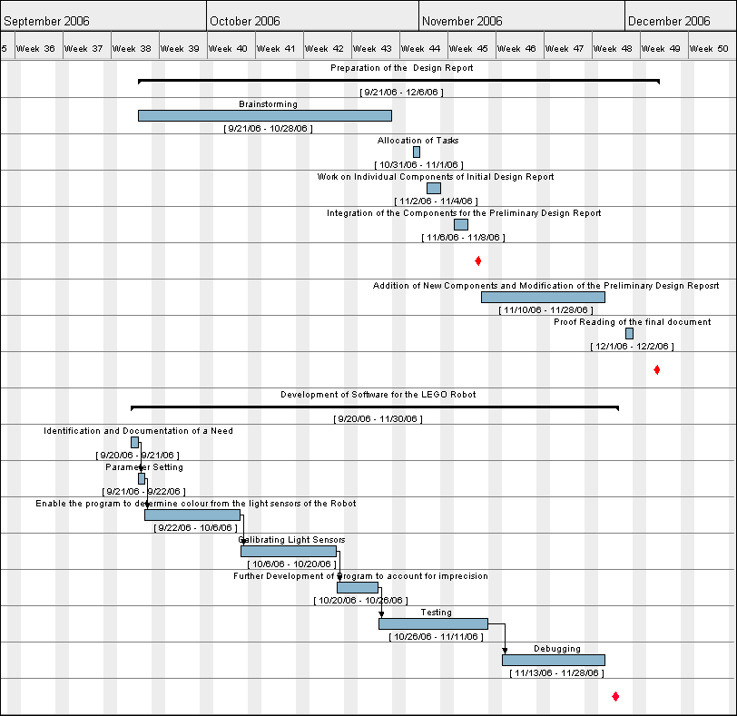
Figure 1 – Gantt Chart of Project Timeline
References

[1] Scholz, Matthias Paul , Brian Bagnall, and Lawrie Griffiths, “The Lejos Tutorial: A practical guide for developers,” The leJos Tutorial, August 21, 2006. [Online]. Available: http://lejos.sourceforge.net/tutorial/index.html [Accessed: Nov. 2, 2006].

